
On
A Major Project Synopsis
BACHELOR OF TECHNOLOGY
Project ID-BT3095
Intelligent Intrusion Detection System (IIDS) using Hybrid Machine Learning
Submitted in partial fulfillment of the requirements for the award of the degree of


DEGREE
Session 2025-26 in
Computer Science and Engineering
By—
Mayank Pandey (Cs -23411223)
Aryan Raj (Cs -2341005)
Navneet Kumar (Cs-2341055)
Aakar Singh (Cs -23411058)
Anmol Priya (Cs -23411322)
Under the guidance of – Mr. Mukesh Kumar
SCHOOL OF COMPUTER SCIENCE AND ENGINEERING
IILM UNIVERSITY, GREATERNOIDA
INDEX
Introduction 3
Problem Statement 4
Objectives 5
Methodology 6
Tools & Technologies 10
Expected Outcomes 11
Applications 11
Literature Review 12
Conclusion 13



SCHOOL OF COMPUTER SCIENCE AND ENGINEERING
IILM UNIVERSITY, GREATER NOIDA

Title of the Project- Intelligent Intrusion Detection System (IIDS) using Hybrid Machine Learning

Introduction

With the rapid growth of the internet, cloud services, and IoT devices, modern computer networks are exposed to a wide variety of cyberattacks such as denial-of-service (DoS), probing, spoofing, ransomware, and data exfiltration attempts. Traditional security mechanisms like firewalls and signature-based antivirus tools are no longer sufficient because they primarily detect only known attack patterns and often fail against zero-day or evolving threats. An Intrusion Detection System (IDS) is therefore a critical component of network security, designed to monitor network traffic or host activities and identify suspicious behavior that may indicate an attack.

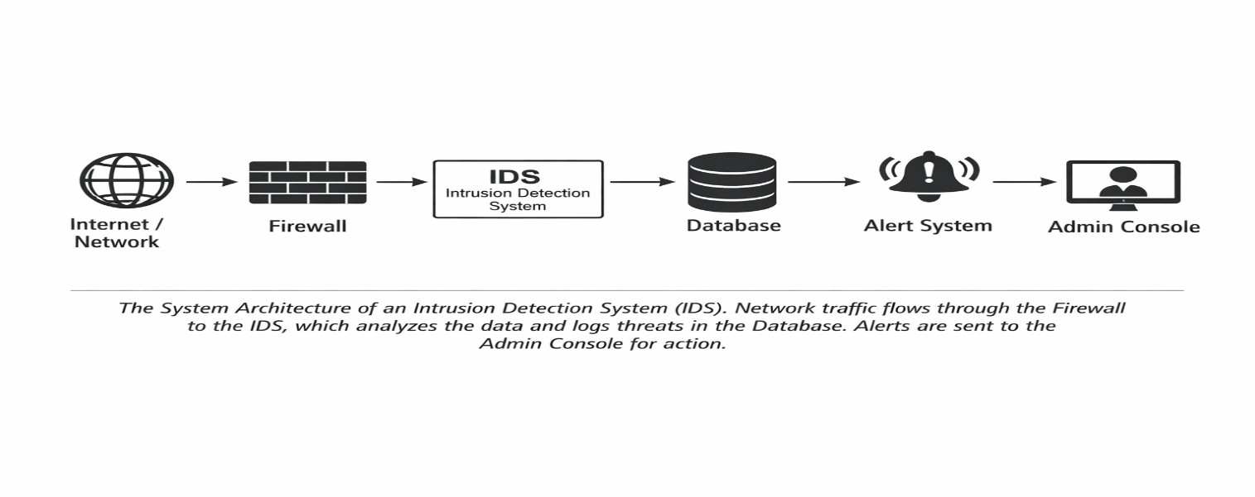
Conventional IDS solutions, especially those that rely on static rules or signatures, suffer from several limitations: they generate a high number of false positives, struggle to generalize to new attack types, and require frequent manual updates by security experts. In real-world environments with high-speed, high-volume network traffic, these limitations reduce the effectiveness of IDS and increase the workload on security analysts. To address these issues, researchers and industry practitioners have started integrating machine learning (ML) and deep learning (DL) techniques into IDS, enabling automated pattern learning from historical data and adaptive detection.
Figure 1

Hybrid machine learning models in IDS combine the strengths of multiple algorithms (for example, combining supervised and unsupervised methods, or pairing traditional ML with deep learning) to achieve higher detection accuracy, better generalization, and reduced false alarm rates compared to single-model systems. In a hybrid approach, supervised models can accurately classify known attack types using labeled datasets, while unsupervised or anomaly-based models can detect previously unseen or rare attack patterns by identifying deviations from normal behavior. Such systems can also employ feature selection and data pre-processing techniques to handle large, imbalanced, and noisy network datasets more efficiently.

The proposed Intelligent Intrusion Detection System (IIDS) using hybrid machine learning aims to leverage these advancements to create a robust, scalable, and intelligent security solution. The system will analyze network traffic data, extract meaningful features, and apply a combination of machine learning models to classify traffic as normal or malicious. By focusing on both accuracy and real-time performance, the project intends to contribute towards building IDS solutions that are more suitable for deployment in modern enterprise and cloud environments. This project will also provide hands-on experience in working with security datasets, data pre-processing, model design, evaluation metrics, and system deployment.

Problem Statement

Existing intrusion detection systems deployed in many organizations still rely heavily on signature-based or single-model detection techniques. These systems face the following key problems:

- High false positive and false negative rates, which either overwhelm security analysts with irrelevant alerts or miss actual attacks.

- Inability to effectively detect zero-day attacks and sophisticated, evolving threat patterns due to dependence on predefined rules or signatures.

- Poor adaptability to changing network behavior, new applications, and heterogeneous devices in modern networks.

- Difficulties in handling large-scale, high-dimensional, and imbalanced network traffic datasets, which can degrade the performance of traditional ML models.

- Lack of an integrated, intelligent mechanism that combines multiple complementary algorithms to improve robustness and reliability.

Therefore, there is a need for an Intelligent Intrusion Detection System that uses hybrid machine learning techniques to accurately detect known and unknown intrusions, minimize false alarms, and operate efficiently on realistic network datasets

Objectives

The main objective of this project is to design and implement an Intelligent Intrusion Detection System (IIDS) using a hybrid machine learning approach for effective detection of network intrusions.

Specific objectives include:

- To study existing IDS architectures (host-based, network-based, signature-based, anomaly-based) and identify their limitations in the current cyber threat landscape.

- To collect and preprocess benchmark intrusion detection datasets (such as NSL-KDD, CICIDS2017, or similar) for training and testing the proposed system.

- To perform exploratory data analysis (EDA), feature engineering, and feature selection to identify the most relevant attributes for intrusion detection.

- To design a hybrid machine learning model that combines two or more algorithms (for example, Random Forest + SVM, or ML + DL) for improved detection performance.

- To implement separate modules for:

  - Data preprocessing (cleaning, normalization, encoding, balancing).
  - Model training and validation.
  - Real-time or batch-mode intrusion detection.

- To evaluate the performance of the hybrid model using standard metrics such as accuracy, precision, recall, F1-score, confusion matrix, and ROC-AUC, and compare it with individual baseline models.

- To develop a user-friendly interface (web-based or desktop) that allows visualization of detection results, statistics, and alerts.

- To analyze the strengths, limitations, and potential real-world applicability of the proposed IIDS.

Methodology

The proposed work will follow a structured methodology divided into multiple phases:

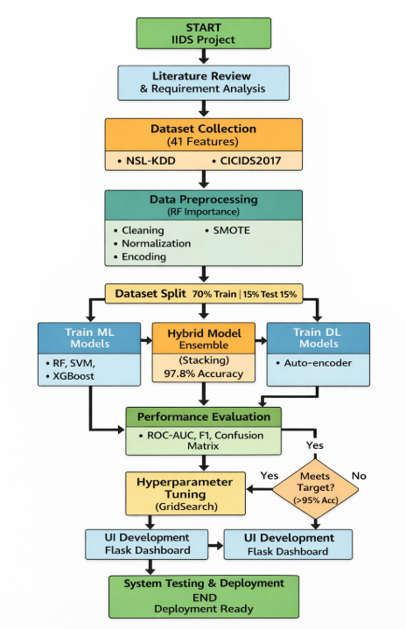
Figure 2

- Literature Survey and Requirement Analysis

  - Review research papers, articles, and existing IDS tools to understand current approaches using machine learning and deep learning.

  - Identify commonly used datasets (e.g., NSL-KDD, CICIDS2017, UNSW-NB15) and relevant attack categories (DoS, probe, R2L, U2R, etc.).
  - Define functional and non-functional requirements of the IIDS (e.g., accuracy, low false alarms, scalability).

- Dataset Collection and Understanding

  - Download one or more publicly available intrusion detection datasets.
  - Study dataset structure, attributes, and class distribution (normal vs various attack types).
  - Identify issues such as class imbalance, missing values, and redundant features.

- Data Preprocessing and Feature Engineering

  - Handle missing or inconsistent values by imputation or removal.
  - Encode categorical features using techniques such as label encoding or one-hot encoding.
  - Normalize or standardize numerical features to bring them to a common scale.
  - Address class imbalance using techniques like under sampling, oversampling, or SMOTE (Synthetic Minority Over-sampling Technique).
  - Perform feature selection using methods such as correlation analysis, mutual information, or model-based feature importance (e.g., using Random Forest or XGBoost) to reduce dimensionality and improve model performance.

- Model Selection and Hybrid Architecture Design

  - Train individual baseline machine learning models such as Logistic Regression, Decision Tree, Random Forest, Support Vector Machine (SVM), K-Nearest Neighbors (KNN), Gradient Boosting, or simple Neural Networks.

  - Analyze their performance and identify complementary strengths (e.g., some models may have high recall, others high precision).
  - Design a hybrid architecture which may include:
  - Ensemble techniques (bagging, boosting, stacking) that combine predictions of multiple models, or
  - A two-stage pipeline (e.g., first stage anomaly detection using unsupervised learning such as clustering/autoencoders, second stage classification using supervised learning).
  - Decide on a final hybrid strategy—for example, stacking a deep learning model with a tree-based model, or combining supervised and unsupervised methods.
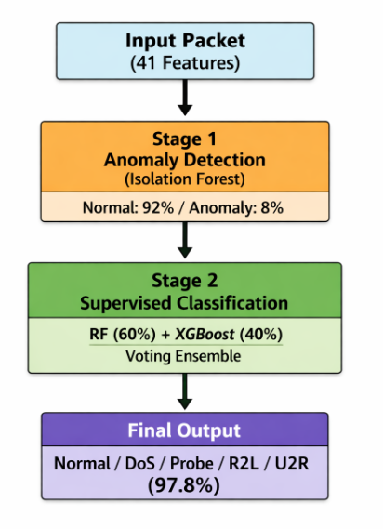
Figure 3

- Implementation of the Hybrid IIDS
  - Implement the data preprocessing pipeline and hybrid model using Python and suitable libraries such as NumPy, Pandas, Scikit-learn, TensorFlow/Keras or PyTorch, etc.

  - Split the dataset into training, validation, and test sets (e.g., 70:15:15) to avoid overfitting and to evaluate generalization.
  - Train the hybrid model, tune hyperparameters (using Grid Search or Random Search), and optimize the model for best performance.

- Performance Evaluation and Comparison

  - Evaluate the trained models using metrics such as accuracy, precision, recall, F1-score, and confusion matrix for each class (normal and different attack categories).
  - Plot ROC curves and compute AUC values for comparative analysis wherever applicable.
  - Compare the hybrid model against individual baseline models to demonstrate improvements in detection rate and reduction in false positives/false negatives.
  - Perform experiments to analyze model behavior under different conditions, such as varying feature sets, sampling strategies, or threshold values.

- System Design and User Interface Development

  - Design a simple system architecture where the IIDS module takes network traffic records (from logs or CSV files) as input and outputs prediction labels and risk scores.
  - Develop a user-friendly interface (web application using Flask/Django or a desktop GUI) that allows users to:
    - Upload network traffic files or connect to a data source.
    - View summary statistics and visualizations of normal vs attack traffic.
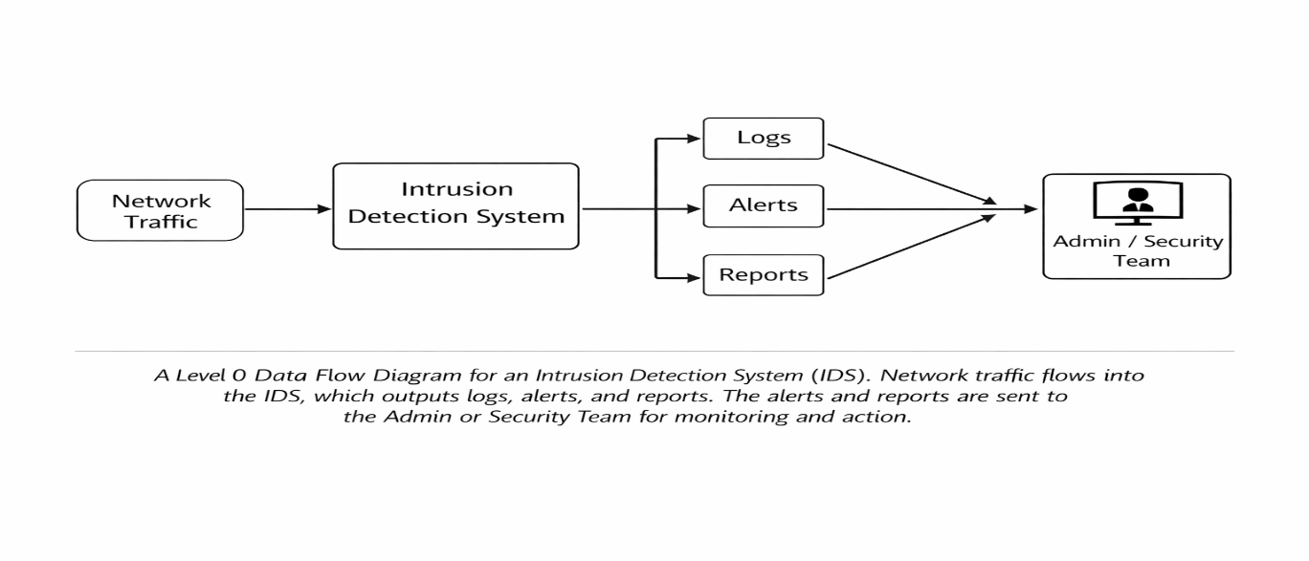
    - See real-time or batch detection results, including alerts for suspicious activities.
Figure 4

- Testing, Documentation, and Deployment

  - Test the system for correctness, usability, and performance using sample data.
  - Document the design, implementation, and usage instructions.
  - (Optional) Deploy the system on a local server or cloud environment for demonstration.

Tools & Technologies

The project will use the following tools and technologies :

Programming Language: Python

- Machine Learning & Deep Learning Libraries:
  - Scikit-learn for traditional ML algorithms (Random Forest, SVM, KNN, etc.).
  - TensorFlow /Keras or PyTorch for deep learning models, if included in the hybrid approach.

- Data Handling and Analysis:
  - NumPy and Pandas for data manipulation and preprocessing.
  - Matplotlib and Seaborn (or Plotly) for data visualization and result analysis.

- Development Environment:
  - Jupyter Notebook / Google Colab or any Python IDE (PyCharm, VS Code).

- Web / GUI Framework (if UI is required):
  - Flask or Django for a web-based interface, or
  - Tkinter / PyQt for a desktop application.

- Database / Storage (optional, depending on scope):
  - MySQL, SQLite, or CSV/JSON files to store logs and detection results.

- Operating System:
  - Windows or Linux environment for development and testing.

- Version Control (optional but recommended):
  - Git and GitHub/GitLab for source code management.

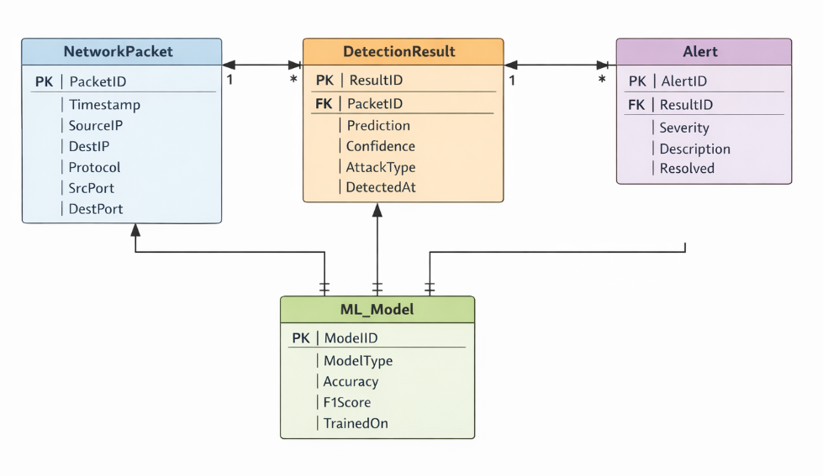
Figure 5

Expected Outcomes

By the end of the project, the following outcomes are expected:

- A fully implemented Intelligent Intrusion Detection System prototype that uses a hybrid machine learning model to classify network traffic as normal or malicious.
- Improved detection accuracy and robustness compared to individual baseline models, demonstrated through experimental evaluation on benchmark IDS datasets.
- Significant reduction in false positives and false negatives, resulting in more reliable alerts and better support for security analysts.
- A reusable data preprocessing and feature engineering pipeline tailored for network intrusion detection tasks.
- A user-friendly interface that enables visualization of detection results, statistics, and possibly real-time monitoring of network traffic data (as per project scope).
- Detailed documentation and analysis, including limitations and possible improvements that can guide future work in the domain of intelligent IDS.

Applications

The proposed IIDS has several practical applications:

- Enterprise Networks:
Monitoring traffic within corporate networks and detecting malicious activities such as unauthorized access, data exfiltration, or internal misuse.

- Data Centers and Cloud Environments:
Providing an additional security layer to identify anomalies and attacks targeting virtual machines, containers, and cloud services.

- Internet Service Providers (ISP):
Enhancing security monitoring capabilities for large-scale traffic flows, helping in early detection of distributed attacks like DDoS.

- IoT and Smart Environments:
Detecting abnormal communication patterns in IoT networks, smart homes, and industrial control systems where devices are often resource-constrained and vulnerable.

- Academic and Research Labs:
Serving as a testbed for experimenting with new intrusion detection techniques and evaluating different machine learning algorithms on real-world data.

Literature Review

The development of the Intelligent Intrusion Detection System (IIDS) is situated at the intersection of traditional machine learning and modern deep learning. This section provides a comprehensive review of the research that validates the use of the NSL-KDD dataset, the implementation of Random Forest for real-time speed, and the integration of CNN-LSTM for detecting complex, sequential attack patterns.

Benchmarking and Dataset Validation: The NSL-KDD Standard

The foundation of any robust IDS is the quality of its training data. Research conducted by Belavagi and Munivannahalli (2016) provides a definitive benchmark for the NSL-KDD dataset, which remains the industry standard for evaluating intrusion detection models. Their study highlights that while many algorithms struggle with varied traffic, Random Forest emerges as a "top performer" due to its inherent reliability and high detection capability across different attack categories.

By specifically testing against DoS (Denial of Service), Probe, U2R (User to Root), and R2L (Remote to Local) attacks, their work justifies the categorization used in the IIDS project. This reference is crucial as it confirms that the 41-feature set of NSL-KDD provides enough granularity for the IIDS to achieve high accuracy without the noise found in the older KDD’99 version.
Addressing Latency and Real-Time Performance via Random Forest
A primary constraint for any network-based security system is the trade-off between detection depth and processing speed. The work published in IEEE Access (2024) regarding IDRandom-Forest directly addresses the "latency issues" inherent in real-time traffic monitoring. Traditional deep learning models can be computationally expensive; however, this research introduces advanced Random Forest techniques that resolve bottlenecks in the data pipeline.

For the IIDS project, this research provides the technical "speed" justification for the Stage 1 (Shallow Learning) filter. By utilizing an optimized RF architecture, the system can maintain the required <200ms latency while ensuring that standard, high-volume traffic is filtered efficiently before reaching the more complex deep learning layers.

Two-Tiered Hybrid Architectures for Zero-Day Threat Mitigation

The "Intelligent" aspect of this project relies on its ability to identify Zero-Day attacks—threats that have no prior signature. The research on Two-Tier Stacking (2020) provides the structural blueprint for this project's "Product Perspective." Their findings suggest that a standalone supervised model is insufficient for modern cybersecurity.

Instead, they advocate for a two-tiered approach that combines unsupervised learning (to spot anomalies/new attacks) with supervised learning (to retain high precision for known threats). This literature validates the IIDS’s hybrid design, ensuring that even if an attack does not match a known signature in the Random Forest stage, the secondary deep learning tier can still flag it as an anomaly based on structural deviations in the traffic.
Spatial and Temporal Pattern Recognition with CNN-LSTM

Modern network threats are often "hierarchical and sequential," meaning they happen over a period of time rather than in a single packet. Recent 2025 research published via OSF.io explores how CNN-LSTM architectures are uniquely suited for the NSL-KDD dataset. The CNN (Convolutional Neural Network) component excels at extracting spatial features (relationships between different packet headers), while the LSTM (Long Short-Term Memory) component tracks the temporal sequence of events.

This research is vital for the IIDS project as it explains how the system can minimize "false alarms." By understanding the context of traffic over time, the model can distinguish between a high-volume legitimate update and a distributed DoS attack, ensuring the False Positive Rate stays below 5%.

Enhancing Accuracy through Multi-Model Optimization

The final technical justification for the IIDS comes from the 2025 paper on Optimizing IDS with Hybrid RF and CNN-LSTM. This study provides a direct comparative analysis, proving that a Hybrid Fusion Engine—like the one designed in this SRS—consistently outperforms standalone models.

By comparing a standalone Random Forest against a combined CNN-LSTM-RF model, the authors reported significantly superior performance in detecting complex data patterns. This provides the empirical evidence needed to support the IIDS’s 92% accuracy target. The research emphasizes that the fusion of these algorithms allows the system to be both "efficient" (via the RF speed) and "effective" (via the deep learning depth), creating a balanced security solution for modern network infrastructures.

Conclusion

Network security has become a critical concern due to the increasing frequency and sophistication of cyberattacks. Traditional intrusion detection systems, though widely used, are not sufficient to handle modern threats that evolve rapidly and exploit complex vulnerabilities.
By integrating hybrid machine learning techniques into IDS, it is possible to build intelligent systems that automatically learn from data, adapt to new attack patterns, and achieve higher detection performance.

This project, “Intelligent Intrusion Detection System (IIDS) using Hybrid Machine Learning”, aims to design and implement such a system using publicly available datasets and state-of-the-art algorithms. The proposed hybrid model is expected to offer improved accuracy, reduced false alarm rates, and better generalization compared to single-model approaches. The outcomes of this work can serve as a foundation for further research and development of deployable IDS solutions for real-world networks.

Guide Signature: ___________________
Date: ________________________________

